Needed Edits
Section 8.3.
In the “download this” zipfile, excel spreadsheet did not have a “Conversion” worksheet. I’m not sure if the past zipfile lacked this. Before we ship the final zipfile, let’s make sure we have this “Conversion” worksheet set up.
Working in the “Conversion” worksheet:
- Check the “GROUPVEG” then the “EVT_PHYS” fields to add them to the Pivot Table. Make sure that GROUPVEG is in the bottom left pane (“Rows”), NOT in the bottom right pane (“Values”). If it’s not, drag the field “GROUPVEG” to the top in the “Rows” pane.
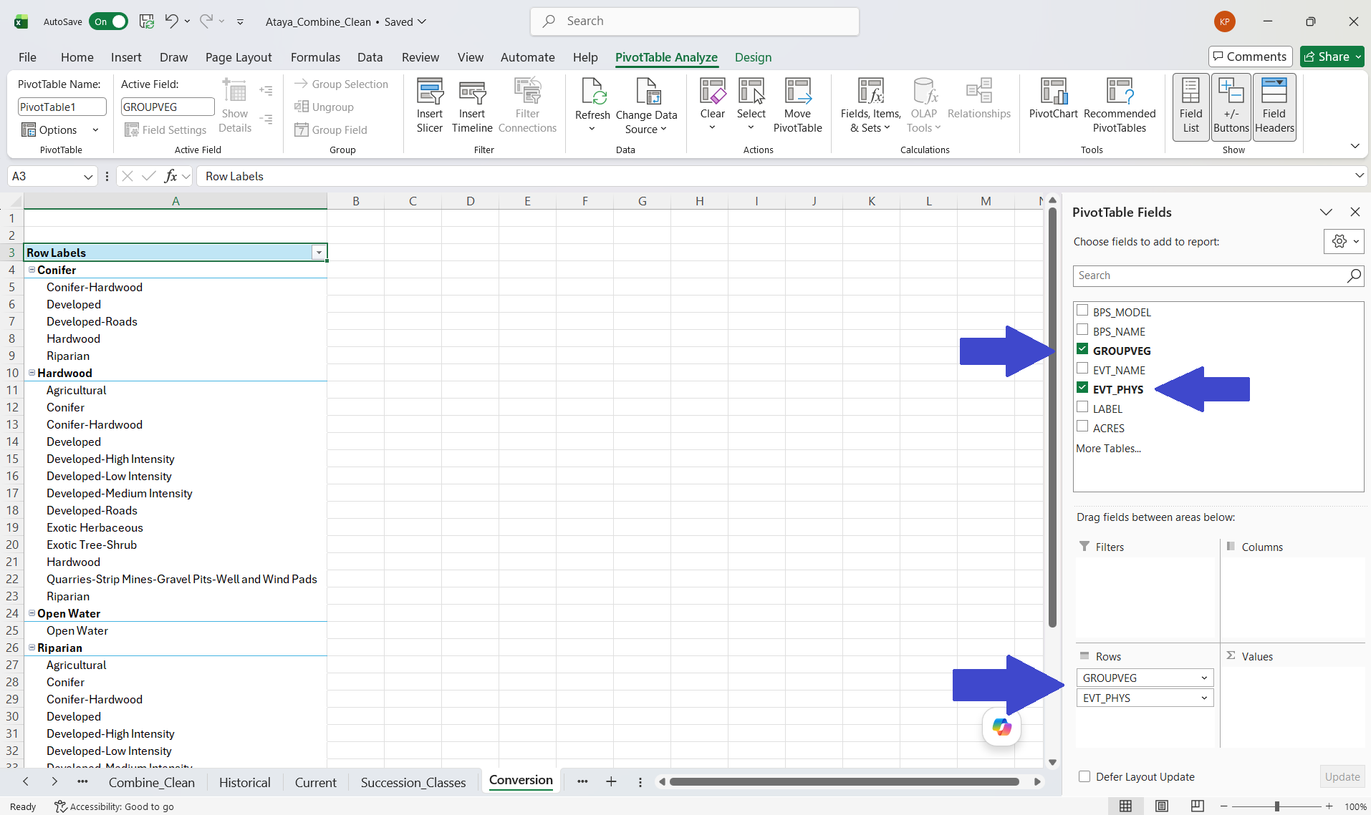
- Create a new column to the left of “Row Labels”. For any bold GROUPVEG value (e.g. Conifer, Hardwood) type “Past” in bold in the cells to the left. For any normal EVT_PHYS value (e.g. Conifer-Hardwood, Developed) type “Present” in the cells to the left. If you fancy, click the dropdown in the “GROUPVEG” header. Here you can remove different types of “GROUPVEG”.
- Check the “ACRES” field to add it to the Pivot Table.
- Explore. Of what was historically mapped as CONIFER, what’s the biggest non-CONIFER type today?
- Switch the order of the fields by dragging “EVT_PHYS” to the top of the Rows pane. Which GROUPVEG type was most converted to “Developed”? Note that our leftmost column—where we labeled “Past” and “Present”—is now switched around. If we switch the GROUPVEG and EVT_PHYS order, make sure we change the “Past” and “Present” values to avoid confusion.
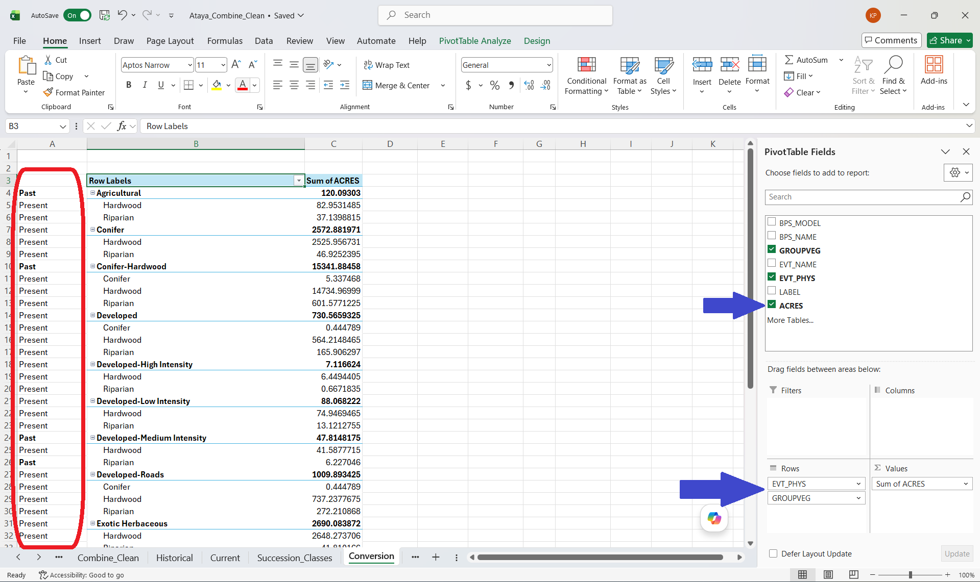
Section 8.4
When you open up the BpS2EVT worksheet, BPS_NAME, EVT_NAME, and Acres were already selected and it appeared an analysis was completed. I suggest we create a fresh pivot table where fields are empty. It did not appear that “COUNT” was selected.
Here are steps to create a table summary which will allow us to view percent change of historical ecosystems (Bps) into current ecosystems (EVT):
- Open the “Bps2evt” worksheet.
- In the Pivot Table, check “BPS_Name”, “EVT_Name”, and “COUNT”.
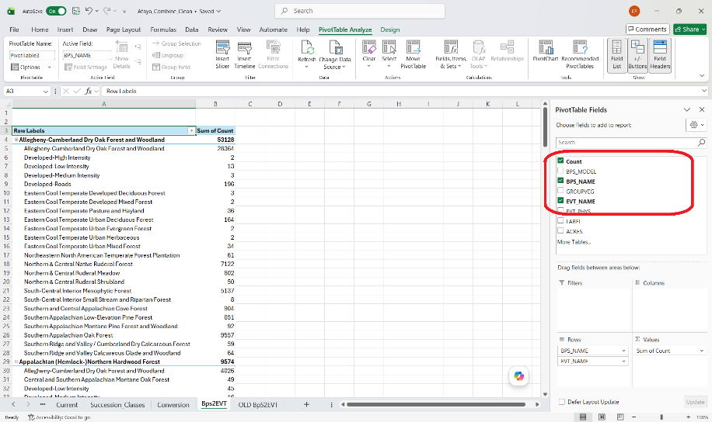
- In the Main Ribbon of the worksheet (where File, Home, Insert, etc. are located) navigate all the way to the last Tab on the right labeled “Design”. Click on “Design”.
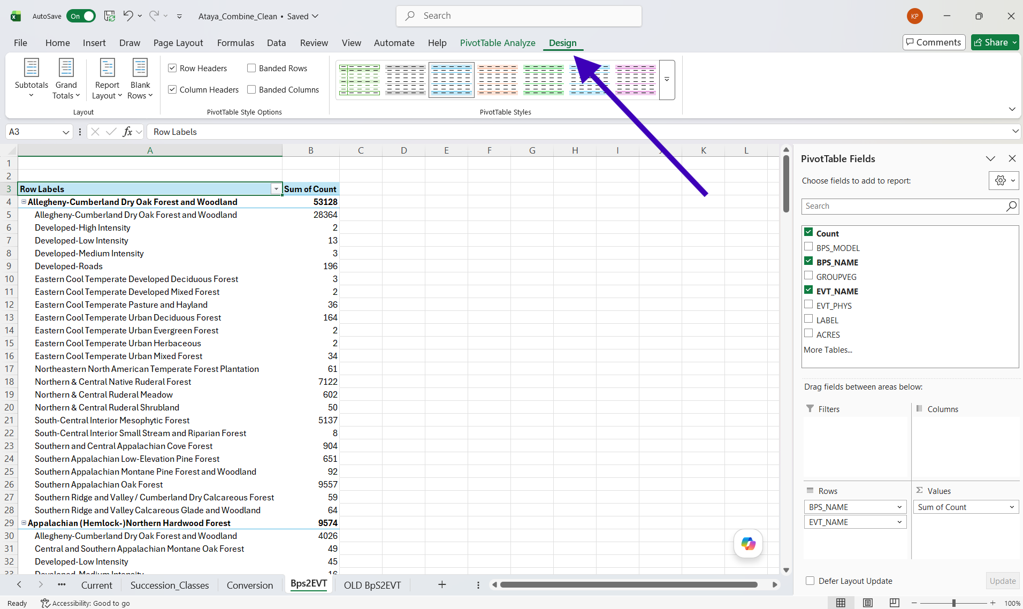
- In the “Subtotals” tab, click on the down arrow and navigate to “Do Not Show Subtotals”. Click on this option.
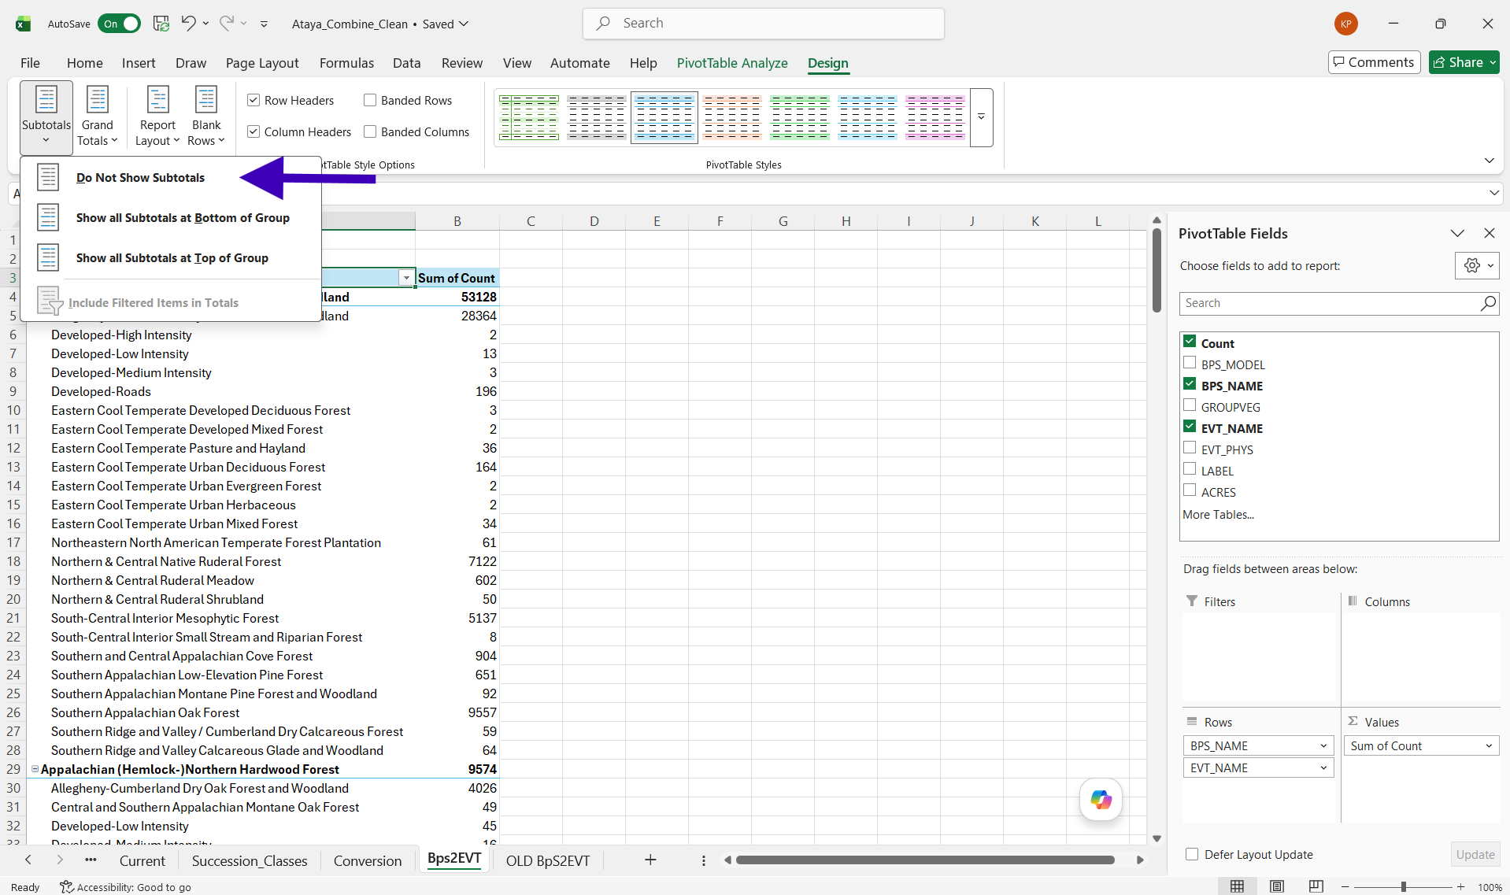
- In the “Grand Totals” tab, click on the down arrow and navigate to “Turn Off for Rows and Columns”. Click on this option.
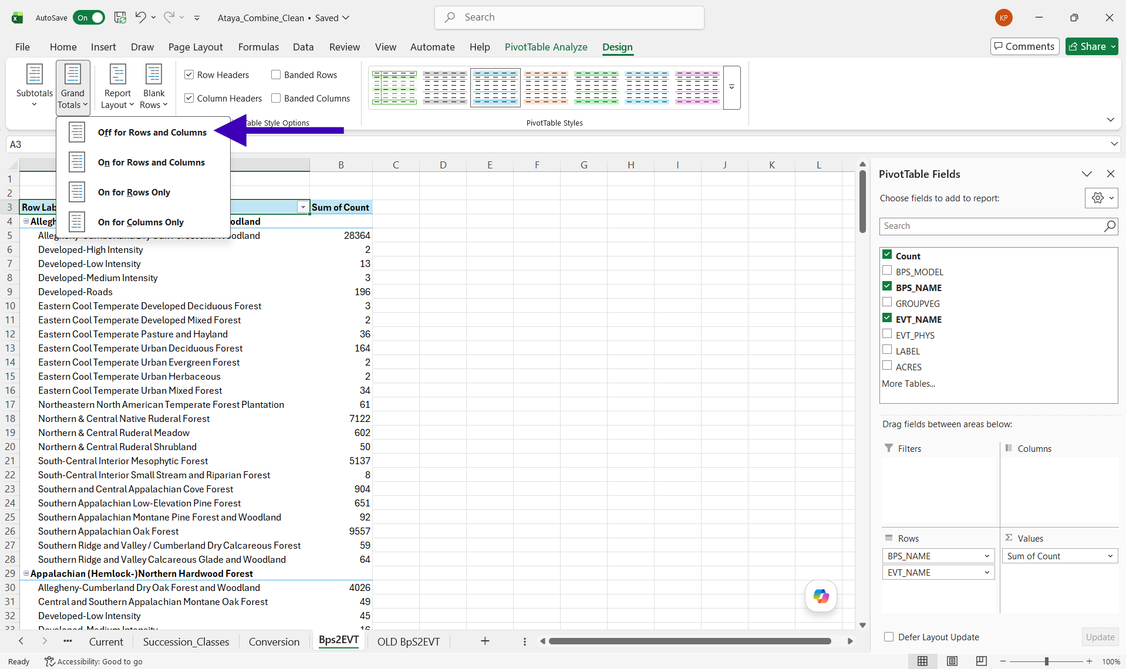
- In the “Report Layout” tab, click on the down arrow and navigate to “Show In Tabular Form”. Click on this option.
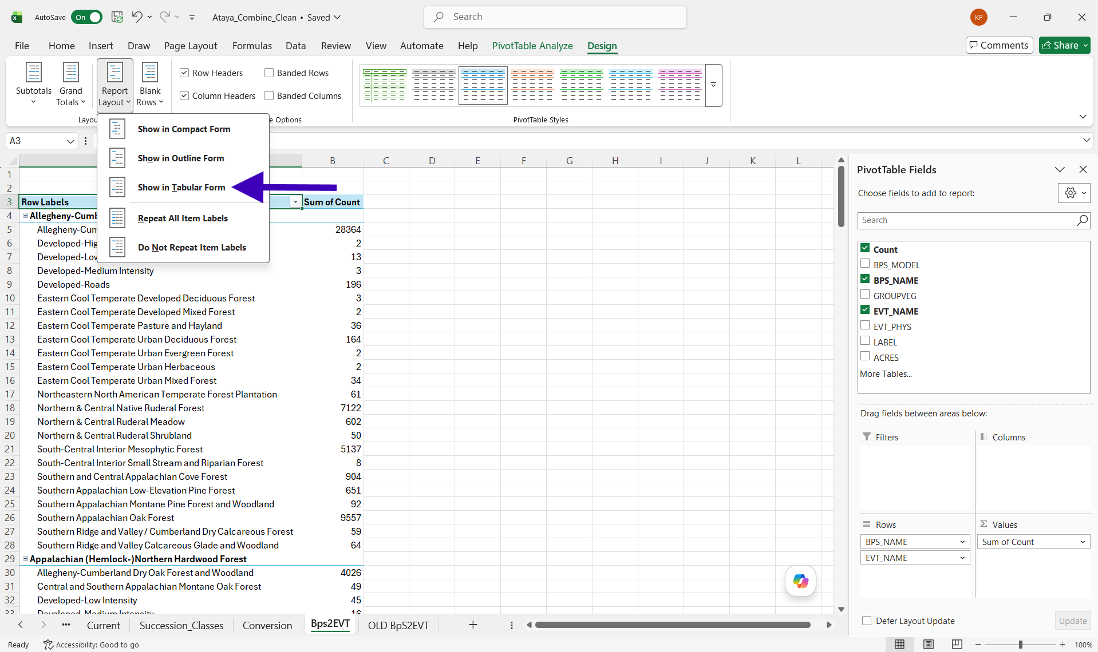
- In the “Report Layout” tab, click on the down arrow and navigate to “Repeat All Item Labels”. Click on this option.
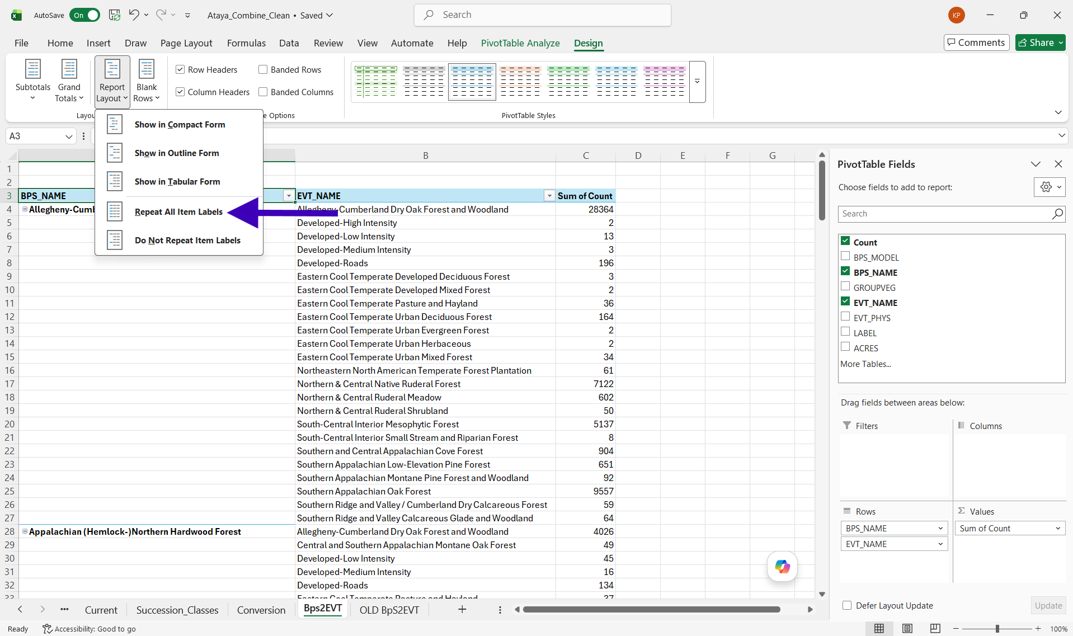
- In the top data cell for the “BPS_Name” data column, right click and navigate to “Filter”. Click on “Top 10…”
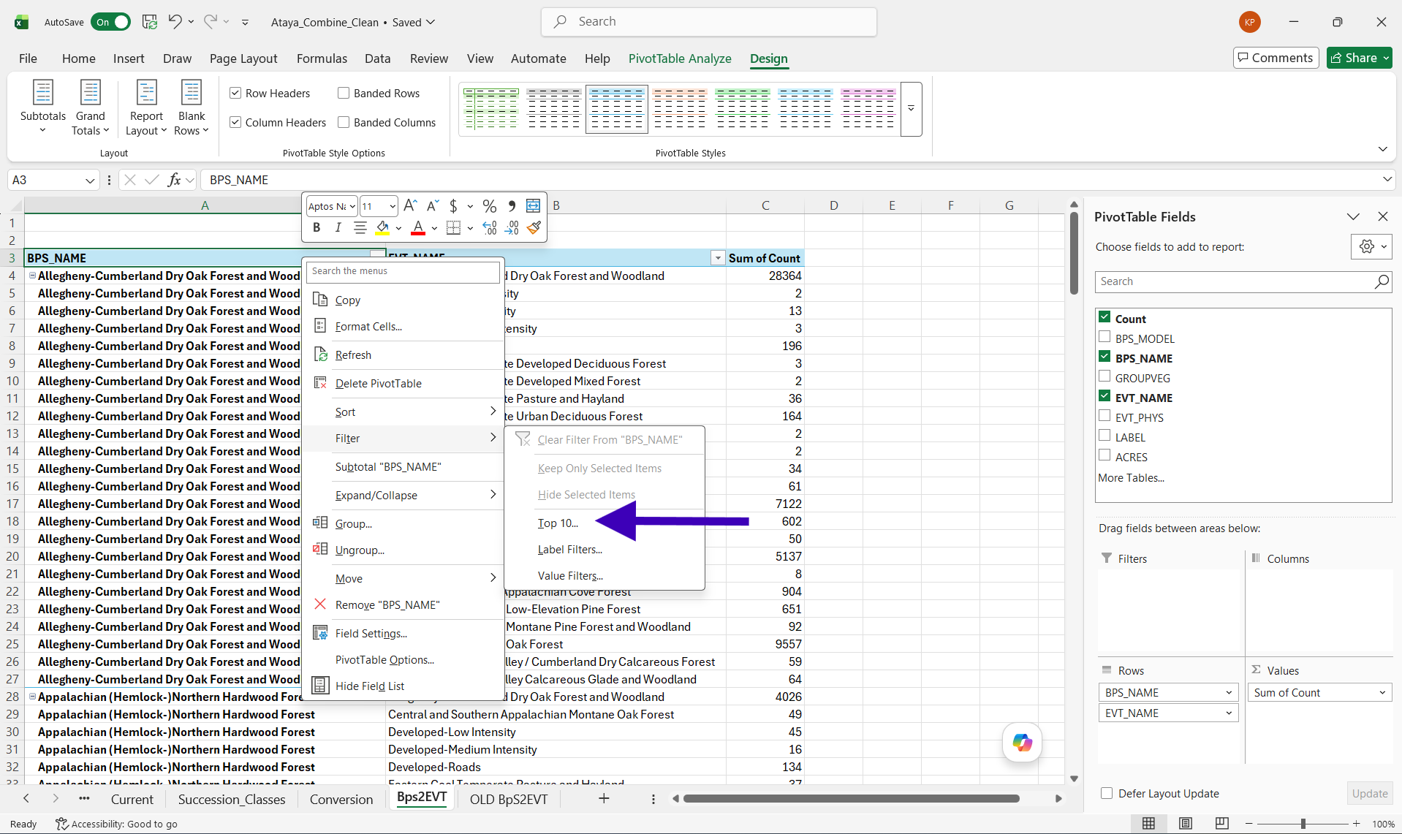

- In the box that opens, change “10” to 90 and “Items” to “Percent”.
  - This will select the top 90% of BpS settings in the Ataya Study Area. To display all BpS, we would type in 100.
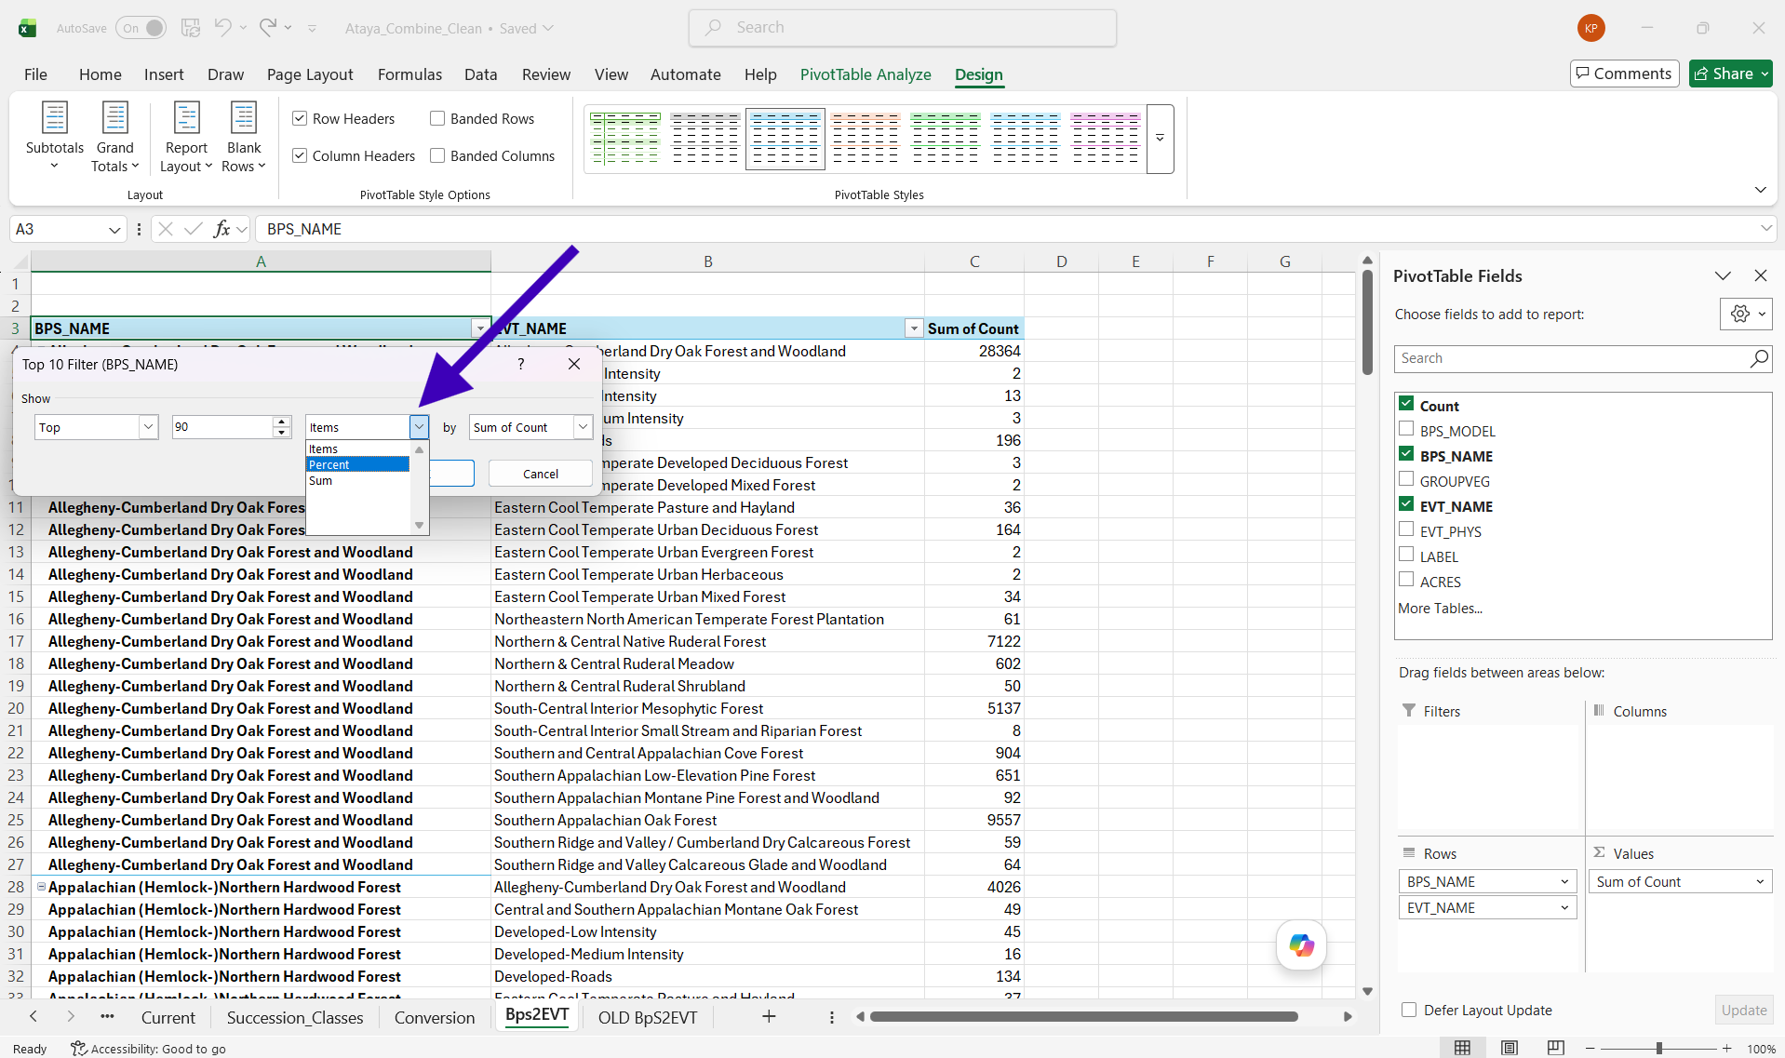
- In the top data cell for the “EVT_Name” data column, right click and navigate to “Filter”. Click on “Top 10…”
- In the box that opens, change “10” to 90 and “Items” to “Percent”.
  - This will select the top 90% of EVT settings in the Ataya Study Area. To display all EVTs, we would type in 100.
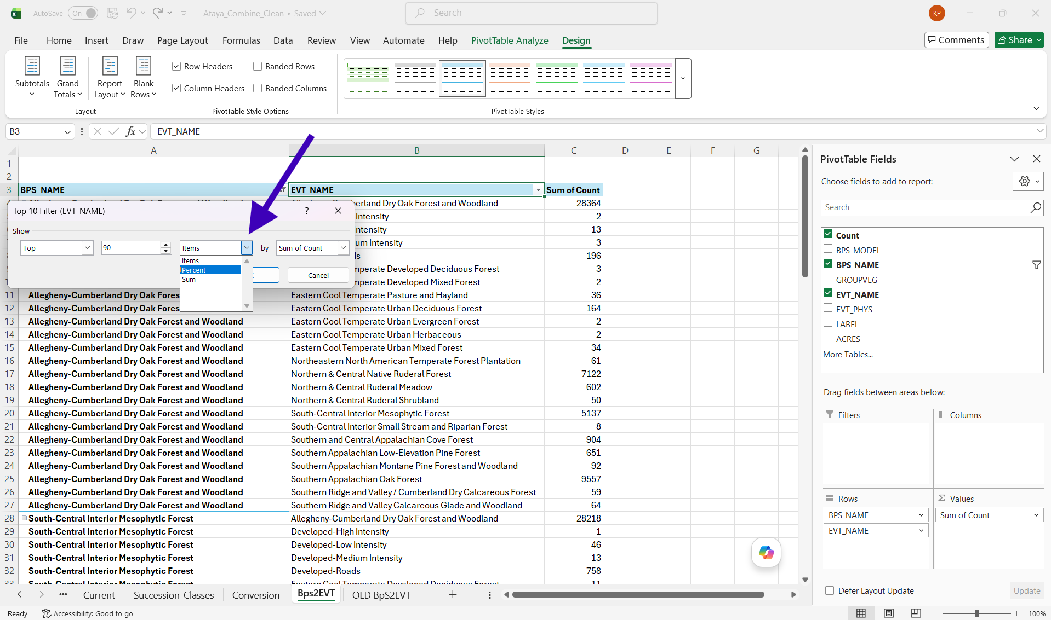
- In the “Sum of Count” data column, right click on the top cell and navigate to “Value Field Settings”.
- In “Value Field Settings”, click on “Show Values As” and navigate to “% of Parent Row total” and click.
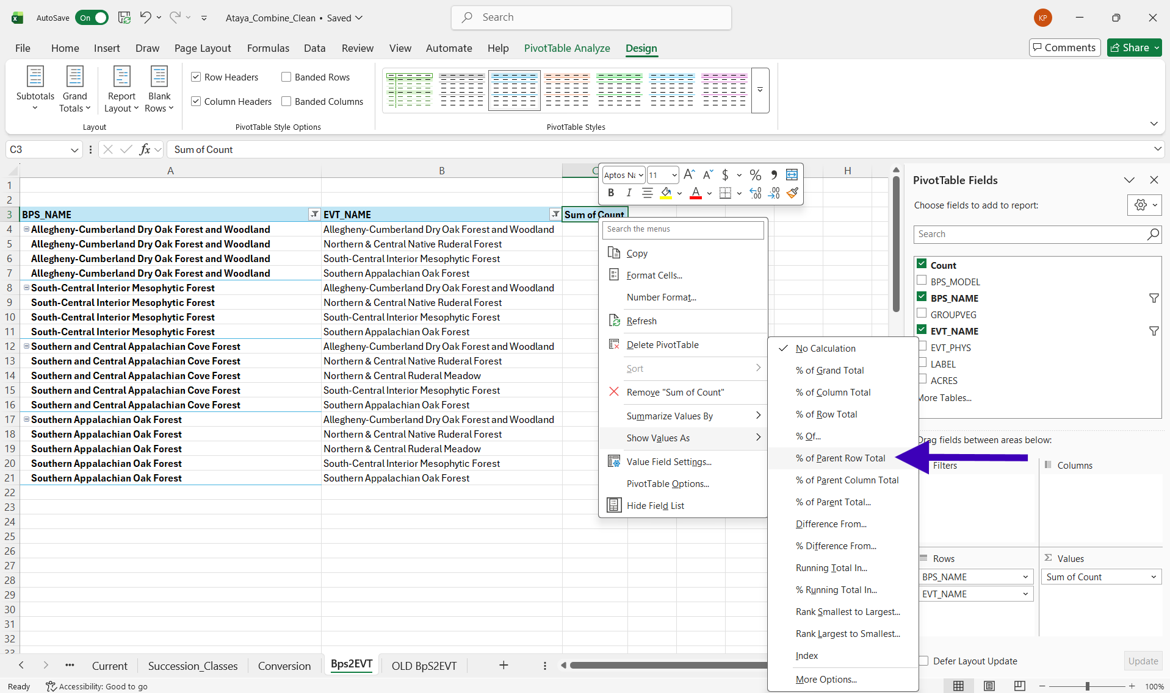
- Change the name of “Sum of Count” to “Percent”.
Voila! We now have a table which should look similar to what’s below. For this tutorial, we have rounded our percents and are only displaying a portion of the table for better website viewing.

